Esports (Valorant) Community Detection

within Twitter using

Louvain, Girvan Newman and Modified Girvan Newman Algorithm

Amita Jain Sayani Ghosal

Amrit Kumar Sharma Vikas Kumar Paras Kumar Akash Sharma

Netaji Subhash University of Technology

nsut.ac.in

***Abstract - We propose a novel method aimed at community detection in social esports networks by combining the Girvan-Newman algorithm with the modularity concept from the Louvain algorithm. Our approach enables the detection to more optimized and more time efficient. In this project, we explore the fascinating world of online gaming communities through the lens of Valorant, a multiplayer first-person shooting game developed by Riot Games. We apply our community detection approach to the Valorant communities on Twitter, which consist of players, streamers, and organizations.***

***Our findings reveal distinct communities for different Valorant agents and different regions. We also observe influential players and organizations that act as center nodes, and smaller communities that form around them. The Louvain algorithm produces the most cohesive communities with the highest modularity scores, while the Girvan-Newman algorithm identifies smaller, more specific sub-communities within the larger communities detected by the Louvain algorithm. Our study contributes to the existing literature on community detection and social networks by providing insights into the Valorant communities on Twitter. It also sheds light on the growing popularity of esports and its potential as a career path for young people.***

**1. Introduction**

While e-sports have become increasingly popular in recent years, there is still much to be learned about the structure and dynamics of e-sports communities. In particular, little is known about the communities that form around individual e-sports players and how these communities impact player performance and game success. Our research aims to address this gap by analyzing the Valorant e-sports community on Twitter and identifying the key players and followers who are driving community engagement and game success. In recent years, e-sports have emerged as a rapidly growing industry, with millions of players and spectators around the world. One of the most popular e-sports games is Valorant, a first-person shooter game developed by Riot Games. As in traditional sports, e-sports players often form communities based on shared interests, skills, and goals. These communities can have a significant impact on players' performance and on the overall success of the game.

In this research paper, we use Twitter data to analyze the communities that have formed around Valorant e-sports players. Specifically, we use network analysis and community detection algorithms to identify groups of players and followers who are connected by shared interests and interactions. We focus on three different algorithms: Louvain, Girvan Newman, and an improved version of Girvan Newman that incorporates the concept of modularity.

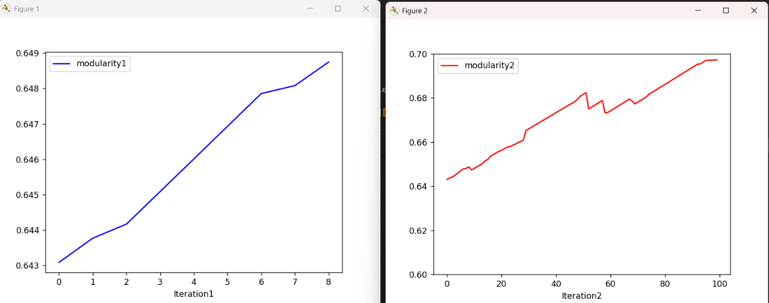

**Modified Girvan Newman Girvan Newman**

Our analysis provides insights into the structure and composition of the Valorant e-sports community on Twitter. We identify different communities based on their shared characteristics and interactions, and analyze the roles of key players and followers within these communities. Our findings have important implications for e-sports game developers and community managers, as well as for players who want to improve their performance and engage more effectively with the e-sports community. By analyzing the Valorant e-sports community on Twitter, our research aims to shed light on the structure and composition of these communities and identify the key players and followers who are driving engagement and game success. Our findings should help to better understand the social dynamics of e-sports and offer tips on how game designers and community managers may interact with players and fans to create more vibrant and successful e-sports communities.

We anticipate that our study will further knowledge of the social dynamics of e-sports and the impact of communities on the popularity of these video games.

**2.METHODOLOGY**

**I. Data Collection**

To collect data for our study, we used the Selenium library in Python to scrape data from Twitter. Specifically, we focused on collecting data related to Valorant players and organizations. We started by identifying popular Valorant players and organizations on Twitter (Total 34). We then used Selenium to navigate to each player or organization's Twitter page and extract information about their followers. In total, we collected data on approximately 33,000 followers across multiple Valorant players and organizations.

Next, we cleaned the data to remove any irrelevant or noisy information. We removed duplicate entries, as well as any followers who did not have a profile picture or who had not tweeted in the past month. We also removed any followers who did not appear to be human, such as spam or bot accounts. After cleaning the data, we were left with approximately 11,400 followers of different Valorant players and organizations. We used this dataset to analyze the community structure within the Valorant Twitter network.

One potential limitation of our data collection method is that it relies on publicly available information on Twitter. This means that our dataset may not capture all of the followers of a given player or organization, and may be subject to biases based on who chooses to follow these accounts on Twitter. However, we believe that our dataset provides a useful starting point for exploring the Valorant Twitter community.

[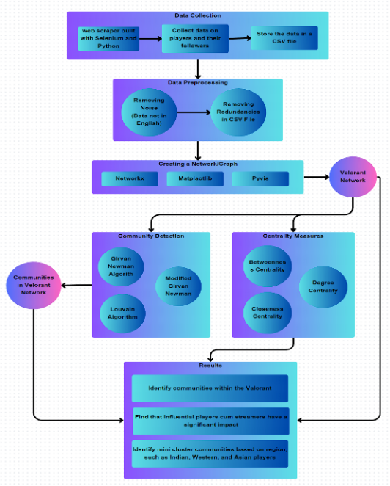](https://www.canva.com/design/DAFe7IpUiVU/jb6qS7Jw9VKdo7gS0G8GEw/edit?utm_content=DAFe7IpUiVU&utm_campaign=designshare&utm_medium=link2&utm_source=sharebutton)

[*Flowchart of Methodology (CTRL+click to view)*](https://www.canva.com/design/DAFe7IpUiVU/jb6qS7Jw9VKdo7gS0G8GEw/edit?utm_content=DAFe7IpUiVU&utm_campaign=designshare&utm_medium=link2&utm_source=sharebutton)

**II. Data Preprocessing**

To prepare our dataset of Valorant Twitter followers for community detection analysis, we performed several steps of data preprocessing. We used Python and several libraries including pandas and numpy for this task.

First, we extracted data on followers rather than tweets. We identified popular Valorant players and organizations on Twitter and used the scrapper to extract data on their followers, including their usernames, follower counts, and account verification status. Next, we used table operations to remove any inconsistencies in the dataset, such as duplicate entries or followers with incomplete information. We also removed any followers who had never tweeted or who had fewer than 2 tweets, as these accounts were unlikely to be active members of the Valorant Twitter community.

To further clean the dataset and remove noise, we filtered out any followers who were not verified by Twitter, as well as any followers who had fewer than 2 followers themselves. We also removed any followers whose account descriptions contained certain keywords or phrases, such as spam or advertisements.

One potential limitation of our data preprocessing approach is that it may have resulted in the removal of some relevant or useful data. However, we believe that the benefits of having a clean and focused dataset outweigh this potential drawback.

**III. Community Detection**

We utilized Louvain, Girvan-Newman, and Girvan-Newman with modularity, three distinct community recognition techniques, to evaluate the structure of the Valorant Twitter network and identify communities within it.

**A. Louvain algorithm**

The Louvain algorithm is a widely used method for community detection in networks. Its fundamental goal is to locate communities of nodes in a way that optimizes the network's modularity. In contrast to the density of linkages between communities, modularity assesses the density of links within communities. A network with a high modularity score has numerous tightly linked groups of nodes and is considered to be highly modular. The Louvain algorithm has two stages. Each node is assigned to its own community in the initial stage. Then, the algorithm iteratively optimizes the modularity score by merging or splitting communities. In the merging step, the algorithm considers merging communities if it results in an increase in modularity. The splitting step considers the reverse: if removing a community from a larger community improves the modularity score, then the smaller community is split off into its own separate community.

Until a maximum modularity score is obtained or no further advancement is possible, this procedure is repeated. A collection of communities that maximizes the modularity score are the end outcome.



* A_ij is the weight of the edge between nodes i and j
* K_i and k_j are the degrees of nodes i and j, respectively
* The network's edge weights are added together to form m.
* c_i and c_j are the communities to which nodes i and j fits.
* δ(c_i,c_j) is 1 if both I and j are members of the same community, 0 otherwise.

**i. Modularity Optimization**

Modularity optimization seeks to maximize the modularity of a given network by finding the best possible division of nodes into communities. This is done by iteratively merging and splitting communities, and calculating the modularity score of the resulting network at each step. The algorithm terminates when no further improvements can be made in the modularity score.

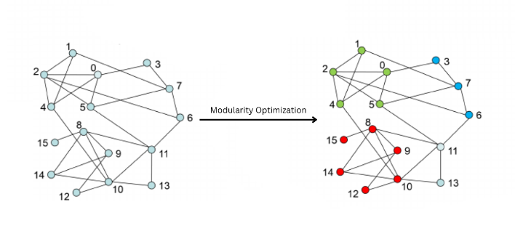

The modularity optimization function contrasts the actual number of connections among communities with the anticipated number of edges if the network were connected arbitrarily. The network's community structure is improved by a greater modularity score. Finding the portion of the network that optimizes the modularity score is the goal of the modularity optimization method.

**ii. Community Aggregation**

The process of community aggregation is usually hierarchical, meaning that smaller communities are first merged into larger ones, and the resulting communities are then merged into even larger ones until a desired level of hierarchy is reached.

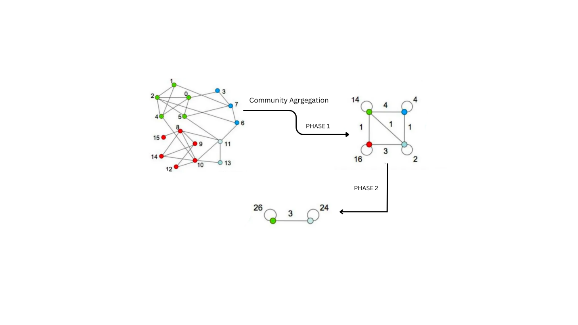

The result can be denoted as a dendrogram, which is a tree-like figure that shows the merging process. Each node in the represents a single node in the original network, while internal nodes (merged community into a single node) represent communities at different levels of hierarchy.

**B. Girvan-Newman Algorithm**

Another popular community discovery technique is the Girvan Newman algorithm. It operates by gradually deleting edges from the network, starting with those that have the highest betweenness centrality (Edge Betweenness Centrality), a metric that indicates how important an edge is in tying together various network components. The method keeps eliminating edges until clusters are formed in the network.

**i. Edge Betweenness Centrality**

Edge betweenness centrality is a metric used to assess an edge's significance inside a network. It is predicated on the notion that some edges are more important than others for linking various nodes. By counting the number of shortest routes that travel through a certain edge in a network, edge betweenness centrality is determined. The greater an edge's betweenness centrality value, the shorter the pathways that cross through it. This result suggests that the edge is essential for tying together various network components and that cutting it off might disclose hidden networks.

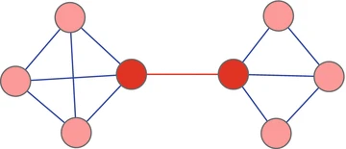

*The red edge in the network shown has all edges' greatest betweenness centrality score.*

**ii. How does it work?**

|  |
| --- |
| **The Girvan-Newman algorithm** |
| 1. *Initialize edge betweenness centrality of all edges in the graph to 0.* 2. *While the number of subnetworks in the graph is less than the desired number of communities:*     1. *Compute the betweenness centrality of every edge in the graph.*    2. *Eliminate the edge with the uppermost betweenness centrality.*    3. *Recalculate the connected components of the graph.* 3. *Output the resulting communities.* |

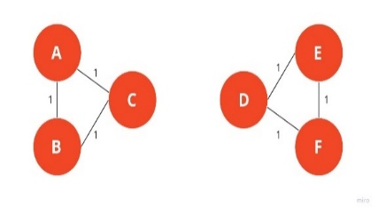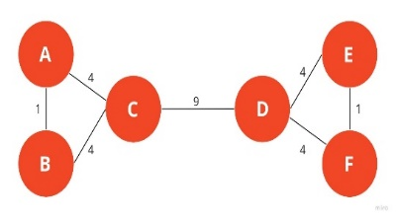

In this example, you can see how a typical graph looks like when **edges are weighted based on the edge betweenness centrality.** To keep things simple, network is undirected. The edge between nodes **A** and **B** has a strength of 1 because we **A->B** and **B->A** is considered as same paths.

The edge connecting nodes C and D is eliminated by the Girvan-Newman algorithm because it has the greatest between centrality. The graph will break into two separate subgraphs if the CD edge is removed, one having the nodes A, B, and C, and the other including nodes D, E, and F. The communities in the Girvan-Newman method will be these two subgraphs. Algorithm stops, If the necessary number of communities is reached or like in the above example final communities are at the point when every edge has the same betweenness centrality.

**C. Modified Girvan-Newman Algorithm with modularity**

To further refine our analysis of the community structure within the Valorant Twitter network, we also used the Girvan-Newman algorithm with modularity. This algorithm incorporates the modularity function used in the Louvain algorithm to optimize the division of the network into communities based on both the density of edges within communities and the modularity of the network as a whole.

|  |
| --- |
| **Modified Girvan-Newman Algorithm** |
| 1. Initialize the betweenness centrality of each edge in the graph G. 2. While True:    1. Calculate the edge betweenness centrality for each edge in the graph G.    2. Compute the modularity of the graph into connected components.    3. Remove edge having highest edge betweenness centrality in graph G.    4. If the modularity of the partition is less than the current maximum modularity,       1. Break:    5. Else:       1. update the current partition and maximize modularity. 3. Return the final partition of the nodes into community. |

The Girvan-Newman algorithm with modularity begins by calculating the betweenness centrality of each edge in the graph. After that, the edges with the highest betweenness centrality are gradually removed, leading the graph to fragment into smaller, linked parts. Edges are removed until the algorithm reaches the required number of communities.

At each step, the algorithm calculates the modularity of the resulting partition of the graph into connected components. If the modularity of the partition is greater than the current maximum modularity, the current partition and maximum modularity are updated.

After applying each of these algorithms to our dataset of Valorant Twitter followers, we visualized the resulting community structures using the Gephi software. We used a modularity score to evaluate the performance of each algorithm and compared the community structures identified by each algorithm to gain a better understanding of the different community structures present within the Valorant Twitter network.

One potential limitation of our community detection approach is that it may not be globally optimizedand proved locally beast solution. However, we believe that using multiple algorithms and visualization tools allows us to gain a more comprehensive understanding of the network and its community structure.

**3. Results**

We collected data on players, their followers, and each follower's follower count on Twitter using a web scraper developed with Selenium and stored the data in a CSV file. We then created a network graph of the Valorant e-sports community using Python, Matplotlib, NetworkX, and Pyvis.

Our network graph consisted of 18,931 nodes representing players and 562,547 edges representing the followers of those players. We applied three community detection algorithms, Louvain, Girvan-Newman, and modified Girvan-Newman (combining the concept of modularity) to analyze the network.

The Louvain algorithm identified 13 communities, while the Girvan-Newman algorithm not major changer in Network. The modified Girvan-Newman algorithm always able increase modularity in the network unlike Girvan-Newman algorithm, but it only removed the highest edge-betweenness edge until the modularity increased. In all three algorithms, famous players, streamers, and organizations were the center nodes of each community.

We drew the network graph for each method to show the outcomes of the community discovery techniques. The network graph for the whole Valorant e-sports community is shown in Figure 1, the Girvan-Newman algorithm network graph is shown in Figure 2, the modified Girvan-Newman algorithm network graph is shown in Figure 3, and the Louvain algorithm network graph is shown in Figure 4.

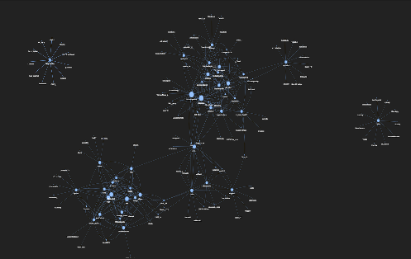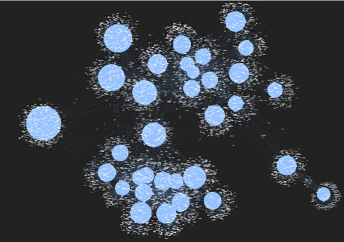

Figure 1: Network graph for the entire Valorant e-sports community

The Girvan-Newman algorithm identified 10 communities within the Valorant e-sports community on Twitter. In this network, the center nodes of each community were famous players, streamers, and organizations. The communities were more fragmented than in the Louvain algorithm network, with more nodes outside of communities. The Girvan-Newman algorithm created communities with less clear boundaries, making it harder to identify key players and organizations within each community.

The modified Girvan-Newman algorithm identified 4 communities within the Valorant e-sports community on Twitter. In this network, the center nodes of each community were famous players, streamers, and organizations.

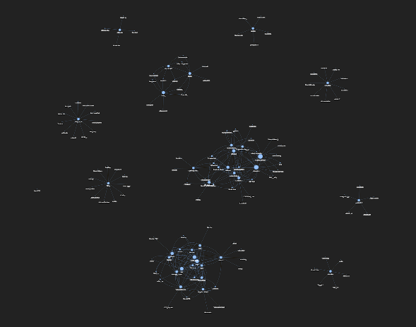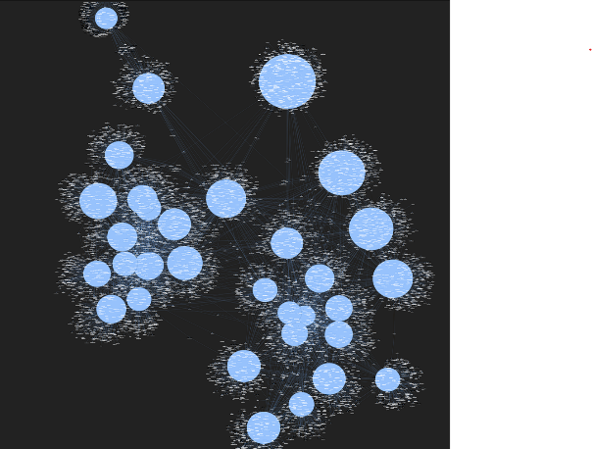

Figure 2: Network graph after applying the Girvan-Newman algorithm

The communities were similar to those in the Girvan-Newman algorithm network, with more fragmented communities and less clear boundaries.

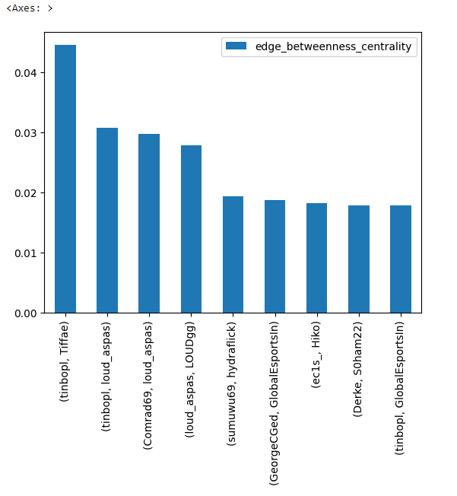

Figure 7: Bar graph for Edge betweenness centrality

However, the modified Girvan-Newman algorithm only removed the highest edge-betweenness edge until the modularity increased, resulting in communities that were more cohesive than those in the Girvan Newman algorithm network.

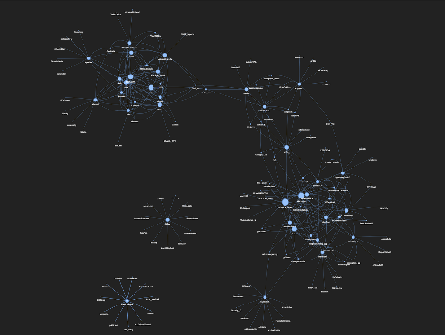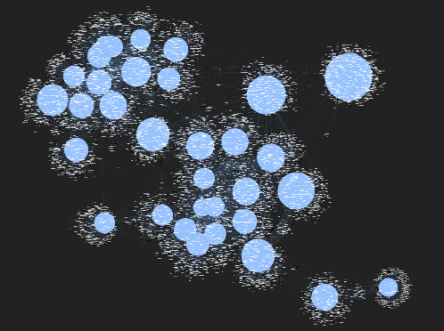

Figure 3: Network graph after applying the modified Girvan-Newman algorithm

The Louvain algorithm identified 13 communities within the Valorant e-sports community on Twitter. In this network, the center nodes of each community were famous players, streamers, and organizations. The communities were interconnected, but each community had its own set of players, streamers, and organizations. The Louvain algorithm created cohesive communities with clear boundaries that allowed us to identify key players and organizations within each community.

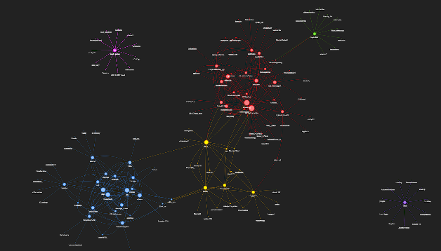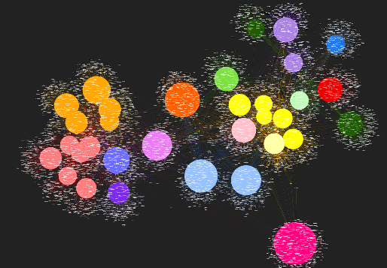

Figure 4: Network graph after applying the Louvain algorithm

We also analyzed the centrality measures of each node to identify important individuals within each community. We used centrality measures to measure the importance of each node.

Our analysis revealed that some players, streamers, and organizations had higher centrality values, indicating their greater importance in the community. For example, Tiffae, suygetsu, Average_Jones, TenZ, and Kyedae had high centrality values in all three centrality measures, indicating their influence and importance in the Valorant e-sports community.

To visualize the importance of each node, we plotted bar graphs for each centrality measure. Figure 5 shows the bar graph for degree centrality, Figure 6 shows the bar graph for closeness centrality, and Figure 7 shows the bar graph for betweenness centrality.

Our analysis provides valuable insights into the structure and dynamics of the Valorant e-sports community on Twitter, which can help community managers and game developers to improve their strategies for community engagement and game development.

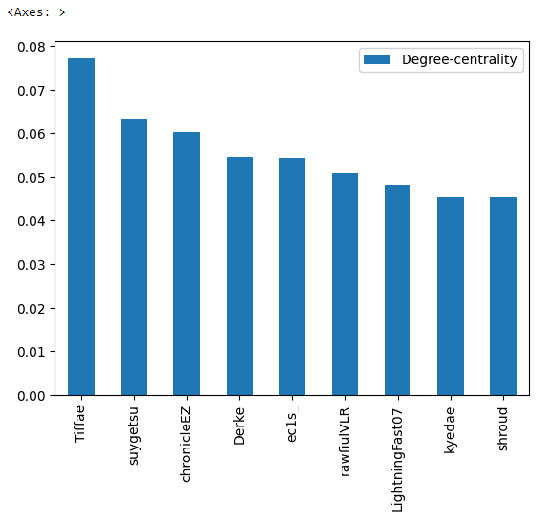 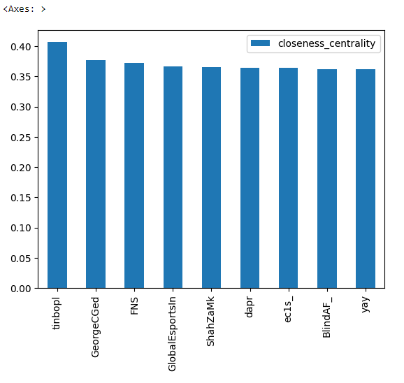

Figure 5: Bar graph for degree centrality Figure 6: Bar graph for closeness centrality

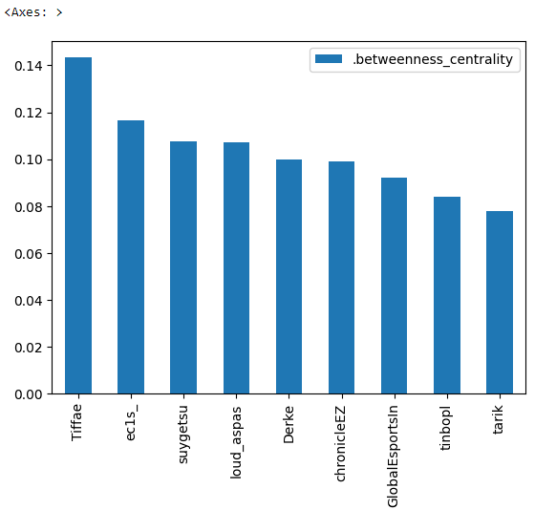

Figure 7: Bar graph for betweenness centrality

**4. Discussion**

Our findings suggest that the Valorant e-sports community on Twitter is highly interconnected, with famous players, streamers, and organizations at the center of each community. These influencers have a noteworthy impact on the development of the community and play a key role in shaping the e-sports landscape. Our results show that famous influencers, streamers, and players cum streamers like Average_Jones, TenZ, Kyedae, Tiffae, and organizations like PlayValorant and GlobalEspots have many nodes surrounding them, indicating that they have a strong influence on the community.

Furthermore, our study identified mini cluster communities based on region, such as Indian players, western players, and Asian players. These mini clusters were interconnected, indicating that the Valorant e-sports community on Twitter is a global community with a diverse range of players from different regions.

**4.1 Related work**

Community detection is a topic that is actively being researched and has received a lot of attention in the literature. Blondel et article's "The Rapid Unfolding of Communities in Massive Networks," provides a quick and effective approach for detecting communities that is popular owing to its efficiency and scalability. The benefits and drawbacks of various community identification techniques are reviewed by Kumar et al. The comparative comparison of clustering techniques in the context of locating rumour sources in social networks is the main topic of the study by Rahul et al. An extended version of the Louvain method that can handle directed and weighted networks is proposed by De Meo et al. in their paper, "Generalized Louvain Algorithm for Community Identification in Massive Networks."

Table: Comparison of various Community detection research with Different Datasets

|  |  |  |  |  |  |
| --- | --- | --- | --- | --- | --- |
| **Source** | **Algorithm** | **Features** | **Parameters** | **Limitation** | **Dataset** |
| Vincent D Blondel et al J. Stat. Mech. (2008) P10008 | Hierarchical Modularity optimization | handle unprecedented sized networks | Edges, Nodes, modularity | storage of the network in main memory | Belgian mobile phone customers |
| M. Girvan and M. E. J. Newman, “Community structure in social and biological networks, | Divisive clustering | Improve the speed of the algorithm | Edge betweenness, community structure | community structure needs to be already known | Zachary’s Karate Club Study, food web of marine organisms in the Chesapeake Bay |
| Finding community structure in very large networks Aaron Clauset, M. E. J. Newman | Modularity based on Greedy optimization, hierarchical agglomeration algorithm | revealing large-scale patterns, faster than most previous general algorithms | Vertices, Edges, modularity | Very large Dendrograms to visualize | items for sale on the web site of a large on-line retailer, Amazon purchasing network |
| Self-similar community structure in a network of human interactions, R. Guimerà, L. Danon | Optimizing Modularity by simulated annealing | Self-similar community structure, reveal the self-organization in network | No. of partitions, modules, modularity | Small sample size, Limited time period, Generalizability | email communications within a medium sized university |
| A Review on Community Detection Algorithms in Social Networks, Puneet Kumar | Hierarchical clustering, Louvain algorithm, Newman-Girvan algorithm | Detection of Communities in Static and Dynamic Networks | Community, Modularity, Social Networks, Similarity, Betweenness. | to find more better and fast algorithms for  community detection. | No datasets are used. Just tried to give brief explanation about the existing algo's and some approaches to optimize them. |
| Comparative Study of Clustering Approaches in Rumor Source Localization Algorithm in Social Networks, Rahul | Louvain approach, Girvan-Newman Algorithm | Improved performance in terms of the accuracy of estimating rumor in a largescale network. | clustering algorithms, social networks, rumor spreading | detecting the source in the network and making the  source localization algorithm more effective and accurate | “coronavirus” and “COVID-19” worldwide from December 2019 to March 2020, “lockdown” in their tweets |
| Generalized Louvain method for community detection in large networks, Pasquale De | Generalized Louvain Method (GLM) | Novel algorithm (GLM), Mathematical formulation, Experimental evaluation, Open-source implementation | Modularity, Resolution parameter, multi-level optimization, | Limited discussion of practical implications, No analysis of computational complexity | Zachary's karate club, Political blogs, Dolphin social network |

The concept of edge betweenness centrality for community discovery, which is based on the notion of deleting edges with the highest betweenness, is proposed by Girvan and Newman's work. For the purpose of identifying communities, Newman suggests a betweenness centrality metric based on random walks. A modularity optimization strategy for community discovery in complicated networks is put out by Zhang et al. For the purpose of detecting communities, Wang et al. suggest a modularity optimization strategy based on global-local search. Each of these studies offers fresh methods for community discovery while highlighting both the benefits and drawbacks of existing techniques.

**5. Conclusion and future work**

Our study examined the structure and dynamics of the Valorant e-sports community on Twitter using three community detection algorithms. Our analysis revealed a highly interconnected and diverse community with influential players, streamers, and organizations at the center of each community. Our study also highlighted the importance of different centrality measures in identifying key players and organizations within the community. Our findings have important implications for community managers, game developers, and marketers in the e-sports industry.

Future work could focus on exploring the temporal dynamics of the community, analyzing the sentiment of the tweets, and investigating the impact of events such as tournaments and game updates on the community. Additionally, future research could explore the potential for applying machine learning algorithms to predict player behavior and engagement in the community.

Overall, our study provides valuable insights into the structure and dynamics of the Valorant e-sports community on Twitter and contributes to the growing body of research in the e-sports industry.

**6. References**

1. Blondel, V. D., Guillaume, J.-L., Lambiotte, R., & Lefebvre, E. (2008). Fast unfolding of communities in large networks. Journal of Statistical Mechanics: Theory and Experiment, 2008(10), P10008. doi:10.1088/1742-5468/2008/10/p10008
2. Kumar, P., Chawla, P., & Rana, A. (2018). A Review on Community Detection Algorithms in Social Networks. 2018 4th International Conference on Applied and Theoretical Computing and Communication Technology (iCATccT). doi:10.1109/icatcct44854.2018.9001978
3. Kumar, S., Pandey, S., & Gupta, R. (2018). Evaluation and Customization of Community Detection Algorithms in Large Social Networks. 2018 Second International Conference on Computing Methodologies and Communication (ICCMC). doi:10.1109/iccmc.2018.8487507
4. Rahul, S. Srivastava and P. Kumar, "Comparative Study of Clustering Approaches in Rumor Source Localization Algorithm in Social Networks," 2020 International Conference on Electronics and Sustainable Communication Systems (ICESC), Coimbatore, India, 2020, pp. 835-843, doi: 10.1109/ICESC48915.2020.9155799.
5. P. De Meo, E. Ferrara, G. Fiumara and A. Provetti, "Generalized Louvain method for community detection in large networks," 2011 11th International Conference on Intelligent Systems Design and Applications, Cordoba, Spain, 2011, pp. 88-93, doi: 10.1109/ISDA.2011.6121636.
6. Girvan, M., & Newman, M. E. J. (2002). Community structure in social and biological networks. Proceedings of the National Academy of Sciences, 99(12), 7821–7826. doi:10.1073/pnas.122653799
7. Clauset, A., Newman, M. E. J., & Moore, C. (2004). Finding community structure in very large networks. Physical Review E, 70(6). doi:10.1103/physreve.70.066111
8. Guimerà, R., Danon, L., Díaz-Guilera, A., Giralt, F., & Arenas, A. (2003). Self-similar community structure in a network of human interactions. Physical Review E, 68(6). doi:10.1103/physreve.68.065103
9. Newman, M. E. J. (2005). A measure of betweenness centrality based on random walks. Social Networks, 27(1), 39–54. doi:10.1016/j.socnet.2004.11.009
10. X. Que, F. Checconi, F. Petrini and J. A. Gunnels, "Scalable Community Detection with the Louvain Algorithm," 2015 IEEE International Parallel and Distributed Processing Symposium, Hyderabad, India, 2015, pp. 28-37, doi: 10.1109/IPDPS.2015.59.
11. Zhang, X. S., Wang, R. S., Wang, Y., Wang, J., Qiu, Y., Wang, L., & Chen, L. (2009). Modularity optimization in community detection of complex networks. EPL (Europhysics Letters), 87(3), 38002. doi:10.1209/0295-5075/87/38002
12. Xun Wang, C. -D. Wang and J. -H. Lai, "Modularity optimization by Global-Local Search," 2016 International Joint Conference on Neural Networks (IJCNN), Vancouver, BC, Canada, 2016, pp. 840-846, doi: 10.1109/IJCNN.2016.7727287.
13. Riot Games “[How did Valorant become so successful](https://tournafest.com/blog/how-did-valorant-become-so-successful-in-such-a-short-time-span/)” April 2022
14. Das, K., Samanta, S., & Pal, M. (2018). Study on centrality measures in social networks: a survey. Social Network Analysis and Mining, 8(1). doi:10.1007/s13278-018-0493-2
15. Newman, M. E. J., & Girvan, M. (2004). Finding and evaluating community structure in networks. Physical Review E, 69(2). doi:10.1103/physreve.69.026113
16. Mora-Cantallops, M., & Sicilia, M.-Á. (2019). Team efficiency and network structure: The case of professional League of Legends. Social Networks, 58, 105–115. doi:10.1016/j.socnet.2019.03.004
17. Muff, S., Rao, F., & Caflisch, A. (2005). Local modularity measure for network clusterizations. Physical Review E, 72(5). doi:10.1103/physreve.72.056107